**INHA UNIVERSITY TASHKENT**

**DEPARTMENT OF CSE & ICE**

**SPRING SEMESTER 2019**

**SOC 2040 - SYSTEMS PROGRAMMING**

**LAB ASSIGNMENT 3**

**Submitted by**

**Student Name Student ID**

**Group : Sophomore**



**INSTRUCTIONS :**

**- ALL LAB ASSIGNMENTS ARE TO BE COMPLETED IN GROUPS OF MAXIMUM 6 STUDENTS.**

**- LAB ASSIGNMENT REPORT SHOULD BE PREPARED USING THE LAB ASSIGNMENT 3 REPORT TEMPLATE PROVIDED.**

**- ONE HARD COPY OF THE LAB ASSIGNMENT REPORT OF EACH GROUP SHOULD BE HANDED IN AT THE OFFICE BY THE GROUP LEADER.**

**- EVERY MEMBER OF THE TEAM MUST UPLOAD THE SOFTCOPY OF THE REPORT AT THE E- CLASS PORTAL.**

**- FOR ALL PART-A ASSEMBLY LANGUAGE PROGRAMMING PRACTICE QUESTIONS, YOU NEED TO PROVIDE PROGRAM AND RESULTS SCREENSHOTS.**

**- FOR ALL PART-B ASSEMBLY LANGUAGE PROGRAMMING QUESTIONS, YOU NEED TO PROVIDE ALGORITHM, PROGRAM AND RESULTS & PROGRAM SCREENSHOTS.**

**- FOR ALL PART-C QUESTIONS, YOU NEED TO PROVIDE DDD DEBUGGER SCREENSHOTS AFTER EXECUTION OF EACH INSTRUCTION IN TRACE MODE BY SHOWING THE INVOLVED REGISTER CONTENTS, MEMORY CONTENTS AND STACK CONTENTS IN CASE OF STACK OPERATIONS.**

**- ALL FILES CONTAINING ASSEMBLY LANGUAGE PROGRAMS WRITTEN AND EXECUTED FOR ALL THE PART-A, PART-B AND PART-C QUESTIONS SHOULD BE UPLOADED AT THE E-CLASS PORTAL ALONG WITH THE LAB ASSIGNMENT REPORT.**

**- LAST DATE FOR SUBMISSION OF THE LAB ASSIGNMENT REPORT IS 15th MARCH 2019**

**- LATE SUBMISSIONS ARE NOT ENTERTAINED, ADHERE TO THE DEADLINE STRICTLY**

**- READ THE QUESTIONS CORRECTLY & CAREFULLY**

Part-A

1.

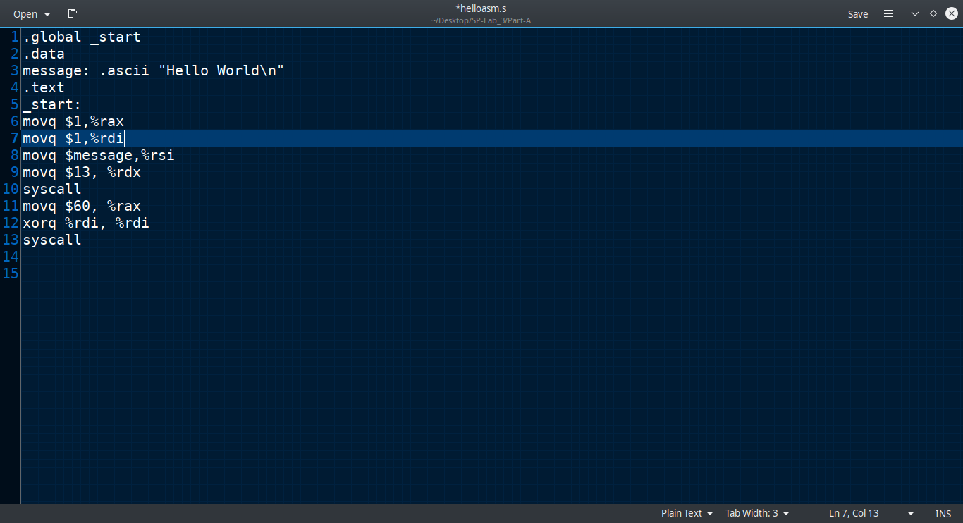

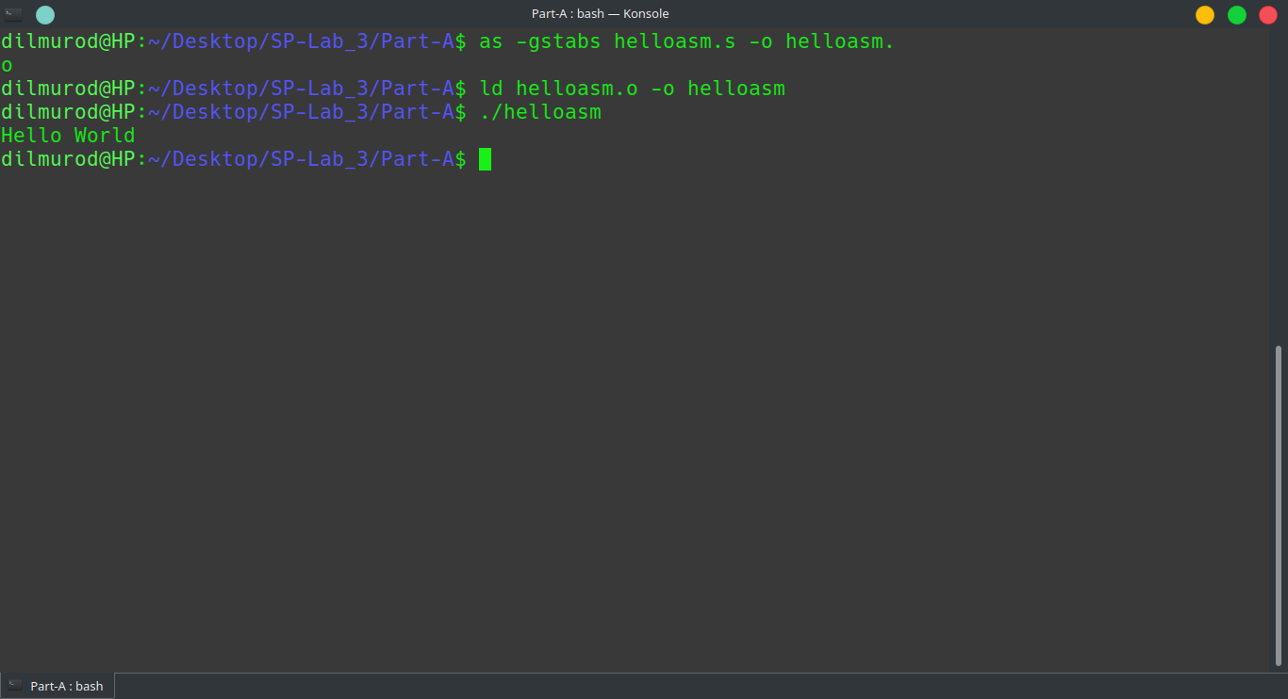

5.

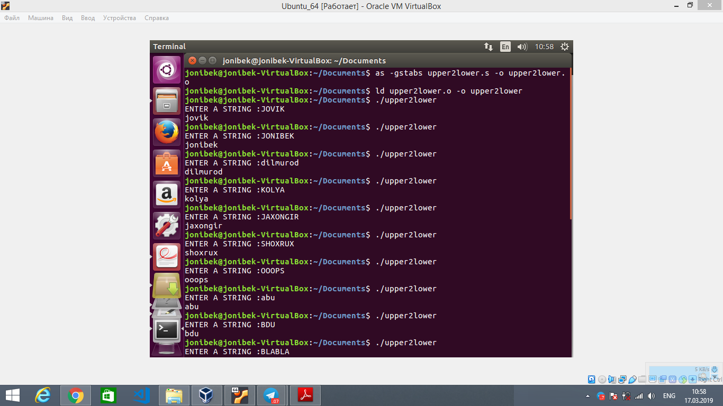

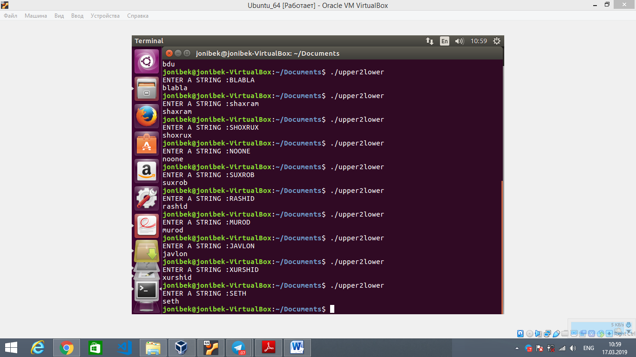

6.

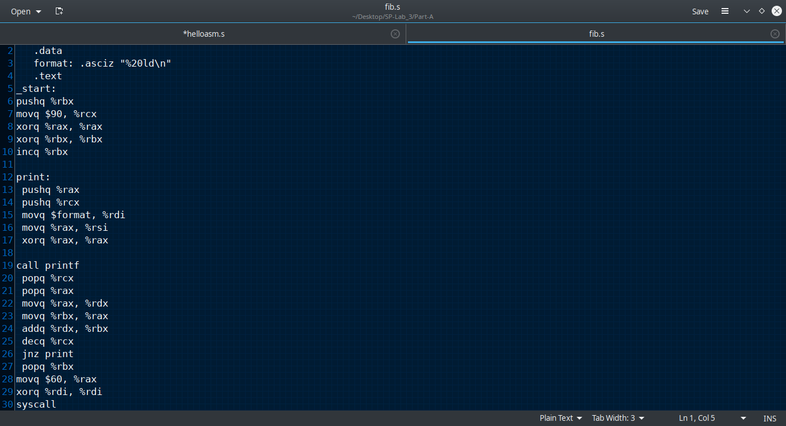

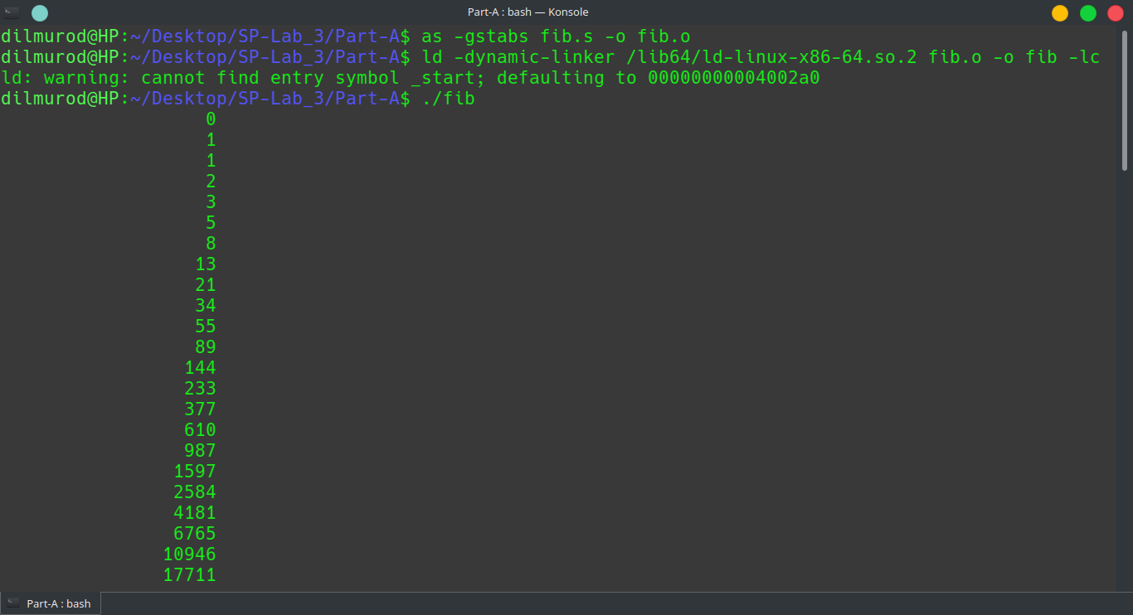

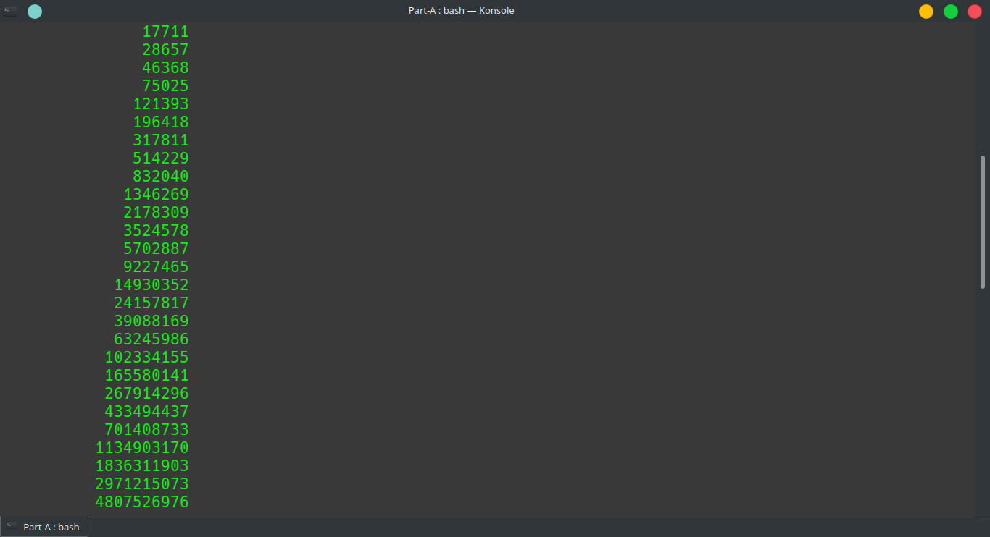

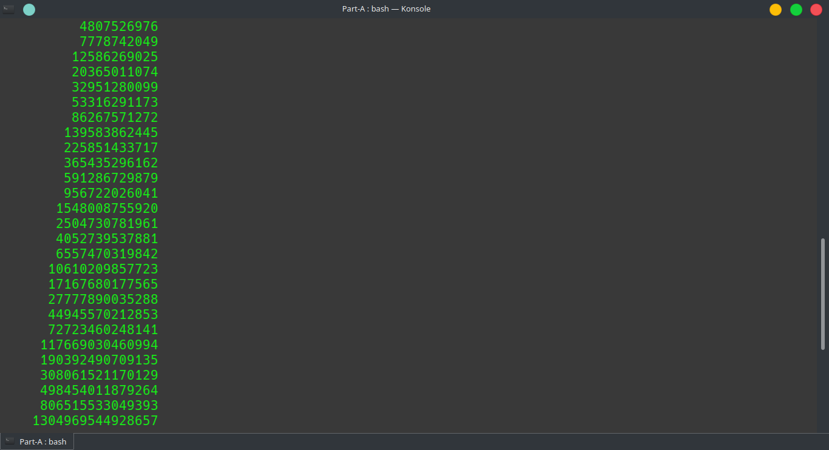

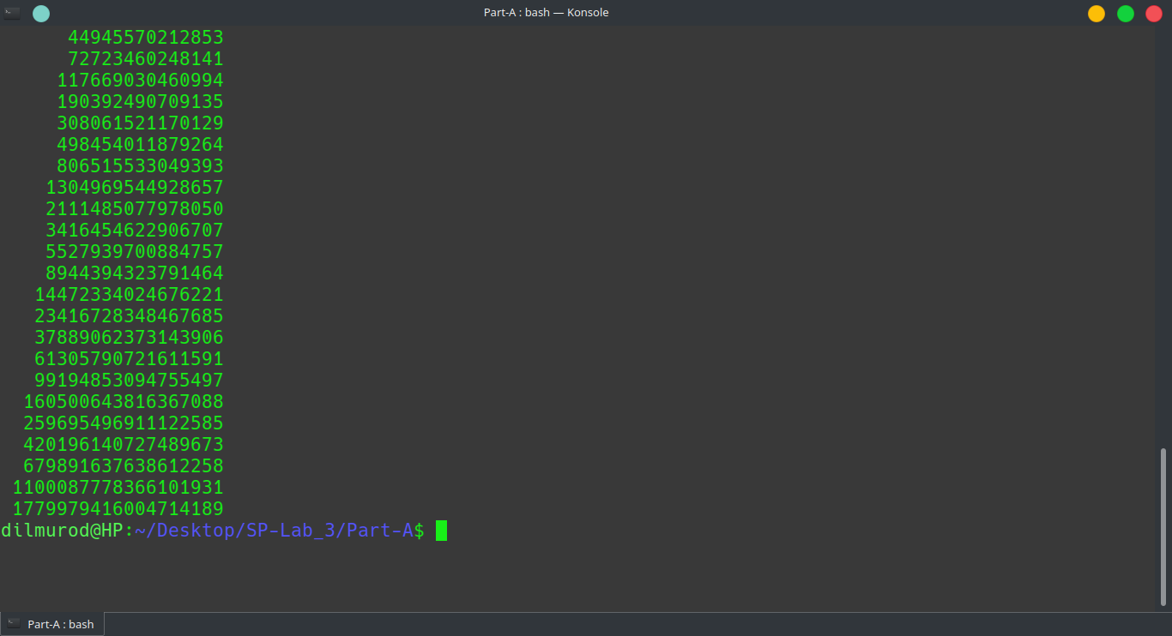

Task15

Write an X86-64 assembly language program to read a string of characters of any length (maximum 1024 characters) from the keyboard and count the number of alphabets, number of numerals, number of special characters (all characters including space - other than alphabets and numerals), total number of characters and total number of words in the string.

.global _start

.data

str: .skip 1024

alphabet: .int 0

special: .int 0

numbers: .int 0

spaces: .int 0

all: .int 0

message1: .string "Enter String: "

message2: .string "\nNumber of alphabets: %d"

message3: .string "\nNumber of numerals: %d"

message4: .string "\nNumber of special characters: %d"

message5: .string "\nTotal number of characters in string: %d"

message6: .string "\nTotal number of words in string: %d\n"

.text

_start:

movq $1, %rdi

movq $1, %rax

movq $message1, %rsi

movq $14, %rdx

syscall

push %rbx

#getting input from user

movq $0, %rax

movq $0, %rdi

movq $str, %rsi

movq $1024, %rdx

syscall

movq %rax, all

movq $0, %r8 #indexer

add $str, %r8 #pointing to base

while:

movb (%r8), %cl

cmp $32, %cl

je spc

#if it is >= 48 then

cmp $48, %cl

jge first

#else it is special character

incq special

done:

incq %r8

movb (%r8), %bl

cmp $10, %bl

jne while

jmp while_end

movq $1, %rax

movq $str, %rsi

syscall

first:

cmp $65, %cl #if it is >= 65 then

jge step_2

cmp $57, %cl #else if it is <= 57 this is number

jle number

#else it is special character

incq special

jmp done

step_2:

cmp $97, %cl #if it is >= 97

jge nextt

#else if it is <= 90 upppercase aplphabet

cmpb $90, %cl

jle alpha

#else it is special character

incq special

jmp done

nextt:

cmp $122, %cl #if it is <= 122 it is alphabet

jle alpha

#else it is special character

incq special

jmp done

spc:

incq spaces

incq special

jmp done

number:

incq numbers

jmp done

alpha:

incq alphabet

jmp done

while_end:

movq $message2, %rdi

movq alphabet, %rsi

xorq %rax, %rax

call printf

movq $message3, %rdi

movq numbers, %rsi

xorq %rax, %rax

call printf

movq $message4, %rdi

movq special, %rsi

xorq %rax, %rax

call printf

decq all

movq $message5, %rdi

movq all, %rsi

xorq %rax, %rax

call printf

incq spaces

movq $message6, %rdi

movq spaces, %rsi

xorq %rax, %rax

call printf

pop %rbx

ret

